**FINAL EXAMINATION** 

|  |  |  |  |
| --- | --- | --- | --- |
| TERM | COURSE NAME | COURSE CODE | VERSION |
| Summer  2020 | Project Management Methodologies | BTS730 | NA |

|  |  |
| --- | --- |
| Name | Khai Phan Thanh |
| Student Number | 100901164 |
| Section | NAA |

DATE: _Aug 13th 2020__________

# EXAM TIME ALLOWED: 2.5 hrs

SUBMISSION WINDOW _24 Hrs ________

PERCENTAGE: __30%_________

TOTAL MARKS: _____100______

PROFESSOR(S): ___Ben Torres ________

SPECIAL INSTRUCTIONS:

1. Please answer all questions and all parts of each question.
2. Write your answers in MS Word and submit via BB.
3. Other special instructions [if necessary]

This exam includes a *cover page*, plus _6 pages of questions.

|  |
| --- |
| SENECA’S ACADEMIC INTEGRITY POLICY |
| As a Seneca student, you must conduct yourself in an honest and trustworthy manner in all aspects of your academic career. A dishonest attempt to obtain an academic advantage is considered an offense, and will not be tolerated by the College. |

APPROVED BY:

Kathy Dumanski, Chair, School of SDDS

# Question 1 – 20 marks

You obtain the table that shows slacks on your **schedule:**

Table 6

-

1:

Free and Total Float or

Slack for Project X

33

Information Technology Project Management, Fifth Edition, Copyright 2007

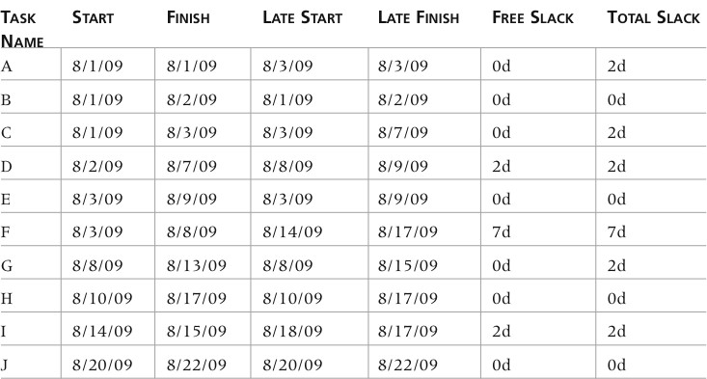

1. Please explain the use of free and total slacks indicated in the table?

* **Free slack** is some of the activities can be delay for a certain amount of time without affecting the early start of next activity, so according to the table, task D and I has an allowance of 2 days for any delay issue (sickness, unaware situation,..) and F has an allowance of 7 days wait time before getting start
* **Total Slack** is the amount of time an activities can be delay without affecting the total project finish date. In the table, Task A, C, D, G, I has an allow slack of 2 days and task F remain to have 7 days

1. Assume that you observe that there are issues with starting tasks at planned dates. How can slacks help you to find a resolution to these issues?

* Slack will help me determine what is my latest starting date for the upcoming and next activities and allow me to determine if this slack affect my schedule deadline or not. If there is a late start activities that is beyond the allowance of free slack or total slack, the rest of the activities slack will need to recalculate.

1. Outline four processes involved in Project Schedule Management & Indicate why they might be important to timely project completion. (Justify Your Responses)

* **Add Milestones to WBS**: an event that is use to “checkpoint” the work before another progress can continue. The Milestone is to ensure activities and works done in the past are correct and following up before starting the next progress. This help to ensure the task perform in that specific milestone are good and satisfy before continue with that. Milestone can be understand as a backup stage where if something happen can resume from there.
* **Outline a Critical Path Method**: a diagram layout use to measure the total project duration. It take the longest path in the diagram that has least amount of slack and float to calculated the expected finish project date. This determine the fastest possible finish date if everything is working out and no problem.
* **Buffer**: additional time allowed to completed a task (if extra time is needed). As closer to the end, some project might requires extra time as while in progress, some of the activity require more time to complete and there isn’t enough buffer or extra time.
* **Critical Chain**: instead of adding additional time for specific task, critical chain will add a total number of extra date to the project before finalizing the due date.

# Question 2 – 20 marks

During the project execution phase your work tasks can be described as “monitoring and control”. It all starts with collecting information from the team members that would help to understand the present situation regarding the task’s completion. You also need to perform regular data input into MS Project tools. Below you see a fragment of an MS Project schedule that contains useful information for tracking purposes. Please review and answer the questions.

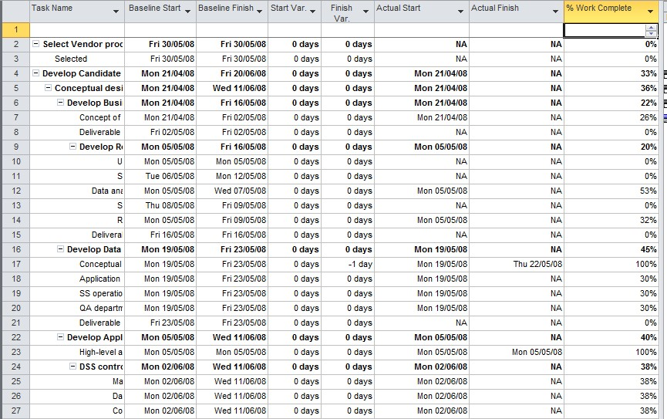

1. At what point in time during your work on the project would the values like “Baseline start” and “Baseline finish” be created? Justify you’re answer. (Explain why).

* Baseline start and finish is created in the planning stage is occur as when they are planning the dates for each of the task. This will give PM and Project Sponsor an idea about the stages and timeline so they can expect what kind of work to complete in specific date in future. Also doing this can allow the project to a have deadline goal.

1. What is the difference between “Baseline start” and “Actual start”?

* Baseline start is an estimated starting date when the project is planned and actual start is when a task is actually start performing or doing.

1. In line 17 you observe the value “-1 day” in the column “Finish Variance”. What does this mean and how are these values calculated?

* It means the project finish earlier than expected. Baseline Finish is when the task is expected to finish but actually the task already finish with less than 1 day to spare.

1. A week later you will be making additional data inputs to track your progress. Which columns from the list below will you use to perform data input? **(PLEASE WRITE OUT YOUR CHOOSEN COLUMNS BY NAME IN YOUR WORD DOC. RESPONSE AND INCLUDE THE APPROPRIATE COLUMN LETTEER AS WELL IN YOUR MS WORD DOCUMENT).**

* I will use the Baseline Finish, Actual Finish and Finish Variance.

1. Why did you choose the columns? Please justify your answers.

* Baseline Finish give me an idea of how long the tasks and project will be and the Actual Finish will help me determine if I am on schedule or not. It doesn’t really matter much in each tasks about the finish date but it does on each overall stage (like Development stage, Design stage, etc.,). Finish Variance will give me any extra date (if there is any available) to measure the upcoming task and events.
* If there is a long difference between an Actual Finish with Baseline Finish (about 10% more than expected), it is the problem for PM to manage the rest of the stage and activities to keep up with the baseline deadline and also to plan for any upcoming risk or unexpected event (like Covid). For this, knowing the Finish Variance will help PM to determine if the project still have any extra allownace date or not.

* 1. Baseline start



x



v



v



v



v



v



v

* 1. **Baseline finish**
  2. Actual start
  3. **Actual finish**
  4. % of work complete
  5. Start variance
  6. **Finish variance**

# Question 3 – 20 marks

To control overall up-to-date progress of your project development you generate an Earned Value table with the help of MS Project tools. You are aware that the project success assumes that it is completed on time as scheduled, and the cost does not exceed the approved budget. You want to control cost and schedule specifically. Please see the table below and answer the questions.

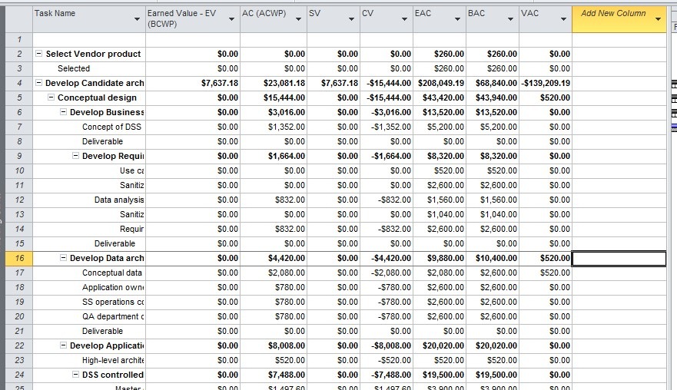

1. Review line 4. The column CV (Cost Variance) contains a negative value. What does this mean regarding the current state of project spending? How would this impact your decision making (your response) as a project manager if your project sponsor asks you to include a last minute new requirement in your project? Justify your answer.

* Negative value represent the cost is currently higher than what is planned. That mean, the overall cost or the Actual Cost is spending over what is actually in the Budgeted Cost. At this stage, the project is currently over the budget. EV represented for baseline cost and AC is the actual spending. When there is a task or tasks that go over the planned budget, it affects the rest of the activities as PM will have to recalculate all the value to cut cost and match with the baseline.
* If there is a new requirement add in the last minute, PM must request Project Sponsor for an increase in baseline as everything was planned and additional task in the last minute will not help PM to address all the cost has spent.

1. Also In line 4, the column SV (Schedule Variance) contains a positive value. What does it mean regarding to the current state of the project schedule? How would this impact your decision making (your response) as a project manager if your project sponsor asks you to include a last minute new requirement in your project? Justify your answer.

* If the Schedule Variance is positive, it means the project is still within its planned duration and nothing has been affected yet. If the Project Sponsor require a last minute requirement, PM must have 2 options available

1. Account for this situation beforehand and have the project scheduled to complete a few days than its actual planned to completed. With this, even if the customer require a last minute requirement, PM can have a flexibility to add it in without affecting the schedule and cost.
2. If all activities are on schedule and there is not much room of flexibility left, PM must request for an additional fund or SV to complete the additional requirements. This also must have prepared and show it to Project Sponsor when this situation arise.

1. How do you determine your projects BAC (Budget at Completion)? How is it calculated and what is the value of this figure to your project?

* BAC is the budgeted amount for each of the task and the total project. Note that sometimes the BAC can higher can EAC because the BAC is calculated when the task is completed and note the actual amount spent. The value in the figure represent for how much the project has been spending at a budget level up-to-now.

1. In line 4, you see (EAC) Estimate at Completion value which is not the same as BAC Budget at completion (much higher). What does this figure mean regarding the current state of the project’s progress? How would this impact your decision making (your response) as a project manager if

your project sponsor asks you to include a last minute new requirement in your project? Justify your answer.

* EAC use formula to calculate what it will cost to complete the project or task base on current team situation. It means that, the amount for each task is the expected amount to spend to complete that certain task and it is a guidelines for IT department and business department to know the spend allowance.
* Since EAC is variables in many different way, the result in the end could be lower or higher than expected. If the result is lower, we can comfortably add another requirement in as there is space in the budget. However, if the cost is much higher, we must request for an additional fund to complete the requirement.

1. A week later, after you update the tracking information, you generate an EV (Earned Value) table again. What do you expect to see in the new version? Will you see the same values? If not, explain why.

* I do expect to see an increase of EV as earned value represent for accumulative value has been earned when a task is completed. It should not in the same values unless you have perform some tasks which doesn’t require any value change such as transferring file to sub-contractor or waiting for something.

# Question 4 – 20 Marks

Topic – Develop a quality management plan for Public Transportation in the Greater Toronto Area (GTA)

Assume that you are part of a volunteer team invited by the Greater Toronto Area (GTA) Transport Authority with the goal to develop initial ideas for GTA Transport Service Improvements.

You want to apply quality management methodology to perform your task.

**To aid your response please note that you are considering public transport which is a public service with a diverse array of potential quality criteria and metrics.**

Please define and describe the following:

1. Determine what category of GTA services you will be working on (Please select (1) one - your choice) you have to reference your choice of service in your responses) o Subway (City Service) o Bus service (City Service) o Government of Ontario (Go-trains-Provincial Service)

* Subway (City Service)

1. Define the quality criteria for the selected service. What criteria will you use to define quality. (5 criteria)

* **Functionality and Features**: create new subway line to accommodate travel through crucial area or working area without any hassle.
* **System output**: traveller must be easy to adapt with the new subway line, especially understand where is it going.
* **Performance**: this new subway line should increase the number of traveller going to and from those crucial area as it is more accesible now.
* **Reliability**: improve the performance currently on bus and other subway line to this one so traveller can see the different and the needs for this new subway line.
* **Maintainability**: it must be available and easy to maintain within the planned and expected time.

1. For each criteria define the metrics that you would use to measure progress. Metrics can be qualitative or quantitative, 3 metrics should be quantitative (numbers)

* **Functionality and Features**: There should be at least 2 more subways line at going to crucial area such as residental area or working area. At this time, bus capacity and quality doesn’t satisfy for this.
* **System output**: The subway line must be easy to travel. It should just going on a straight line (either vertical or horizontal, or even 45 or 60 degrees, avoid and turn where not necessary to confuse traveller).
* **Performance**: For this new subway line, we are expected to have a new subway car with larger room available for high capacity during rush hour. Traveller should feel comfortable waiting and while on travel.
* **Reliability**: The new subway expect to solve the problem of bus service. From an expected 45 minutes bus ride can be turn into 20-25 minutes of subway ride.
* **Maintainability**: Since this subway line will be much similar to exisitng subway, maintainability isn’t require much. However, because of the new subway car, we might need a new team to specialize for maintaining the subway car.

1. Define Quality control checkpoints, in other words, determine how you will perform measurements.

* **1st check-point** is to compare the actual time travelling on bus and subway (ideal time, fastest possible and during rush hour).
* **2nd check-point** is to have the number of traveller prove itself for the performance. If the subway is really more convenience and accessble, more traveller will use the subway instead of bus.
* **3rd check-point** is to understand and know the traveller complain as well as experience on the new subway (if they are positive with the number of stop, locate each of the stop and know where they are going).
* **4th and last check-point** is to measure the maintainance of the subway car and the track (if they are within the designate time or required more).

1. Determine what kind of resources (financial, human, time) would be needed to establish quality control based on your criteria.

* We would require mostly human to construct, plan the subway and traveller for their experience. For time and financial, it is vary between tasks and will specify later.

1. Document your plan in MS Word or MS Excel table (Excel Preferable) with the following structure.

**GTA Public Transportation Service : Subway Service**

|  |  |  |  |  |
| --- | --- | --- | --- | --- |
| **#** | **Quality Criteria (5)** | **Metric definition. Qualitative &**  **Quantitative** | **Control checkpoints – How is quality measured.** | **Resources required to establish quality control** |
| 1 | **Functionality and Features**: create new subway line to accommodate travel through crucial area or working area without any hassle. | **Functionality and Features**: There should be at least 2 more subways line at going to crucial area such as residental area or working area. At this time, bus capacity and quality doesn’t satisfy for this. | **2nd check-point** is to have the number of traveller prove itself for the performance. If the subway is really more convenience and accessble, more traveller will use the subway instead of bus. | Human and Financial to plan for the new subway line. |
| 2 | **System output**: traveller must be easy to adapt with the new subway line, especially understand where is it going. | **System output**: The subway line must be easy to travel. It should just going on a straight line (either vertical or horizontal, or even 45 or 60 degrees, avoid and turn where not necessary to confuse traveller). | **3rd check-point** is to understand and know the traveller complain as well as experience on the new subway (if they are positive with the number of stop, locate each of the stop and know where they are going). | Human as travellers to experience the new subway and time to test it. |
| 3 | **Performance**: this new subway line should increase the number of traveller going to and from those crucial area as it is more accesible now. | **Performance**: For this new subway line, we are expected to have a new subway car with larger room available for high capacity during rush hour. Traveller should feel comfortable waiting and while on travel |  | Financial as more traveller will increase more financial and number of traveller to test for its effectiveness. |
| 4 | **Reliability**: improve the performance currently on bus and other subway line to this one so traveller can see the different and the needs for this new subway line. | **Reliability**: The new subway expect to solve the problem of bus service. From an expected 45 minutes bus ride can be turn into 20-25 minutes of subway ride. | **1st check-point** is to compare the actual time travelling on bus and subway (ideal time, fastest possible and during rush hour). | Human as tester for time testing and understand its effectiveness compared to old method. |
| 5 | **Maintainability**: it must be available and easy to maintain within the planned and expected time. | **Maintainability**: Since this subway line will be much similar to exisitng subway, maintainability isn’t require much. However, because of the new subway car, we might need a new team to specialize for maintaining the subway car | **4th and last check-point** is to measure the maintainance of the subway car and the track (if they are within the designate time or required more). | Human as worker to maintain the subway car and track and time use to perform the maintanance. |

# Question 5 – 20 Marks

**Please assume a Pre-Covid Communications Scenario when answering this question.**

You are an external project manager working for a consulting company on an IT implementation project for a client in the highly regulated financial services industry. Your end client is publicly traded and is unionized. Your organisation (the consulting company) is publicly traded.

You report into a project director at your company as well as the VP of business development who won this contract. You are managing a culturally diverse international team with varied skillsets.

You also report into client stakeholders including the project sponsor who is a VP, the clients technical lead, subject matter experts, and union representatives.

**Please answer these questions: (Please provide justification for your responses)**

1. What are three (3) keys to effective communications management in a project environment.

* Planning, Performance Reporting and Stakeholder Management

1. What are you as a project manager trying to achieve by effective communications management.

* Know the audience to express and talk about the content of the project (such as financial, progress, IT issue, etc.,). From that, establish proper delivery method for best communication and the frequency of those. Also point out who should be responsible for each audience, as sometimes Project Manager isn’t the best option of contact.

1. Use MS Excel or Word (Not PDF) to develop a project communications plan encompassing the stakeholders mentioned.
   1. Your direct report
   2. Your VP of Sales
   3. The Client Project Sponsor
   4. Your international team
   5. The client’s Technical Lead &
   6. The client’s subject matter experts
   7. The Union representatives

Please include these headings in your plan for each stakeholder type mention above.

* 1. The type of communication
  2. Objective of the communication
  3. The medium of communication
  4. The audience
  5. Typical Topic that will be addressed in your communication to this stakeholder

|  |  |  |  |  |  |
| --- | --- | --- | --- | --- | --- |
| Audience | Content | Medium for Delivery | Frequency / Timing | Communication Deliverable | Who is responsible |
| Direct Report | Current report of the project | Presentation / Meeting | Bi-Weekly | Report of the current stage in project | Project Manager |
| VP of Sales | Current state of financial | Hard Copy / Presentation / Meeting | Weekly | Report of all spending and activies performed | Project Manager |
| Client/Project Sponsor | Resources spending, Current project progress | Email / Telephone Call | Bi-Weekly | Project monitoring report, quickly address and present all the financial numbers | Project Manager |
| International Team (I assume this is outsource team) | Current project progress and task acitivity monitoring | Email / Telephone Call | Twice a week | Task monitoring and result of current progress | Project Manager |
| Technical Lead | Current project progress, existing issue | Meeting / Telephone Call | Twice a week | Decision and issue log. Program issue log. | IT team |
| Subject Matter expert | Current state of planned financial and progress | Email | Weekly | Report of financial spending and result of current progress | IT team |
| Union rep. | Current stage of progress | Email | Weekly | Result of current progress | IT team & Project Manager |